English
F5CA Stronger Starts
Local First 5 Newsletter & Social Media Copy

Newsletter

Asset:
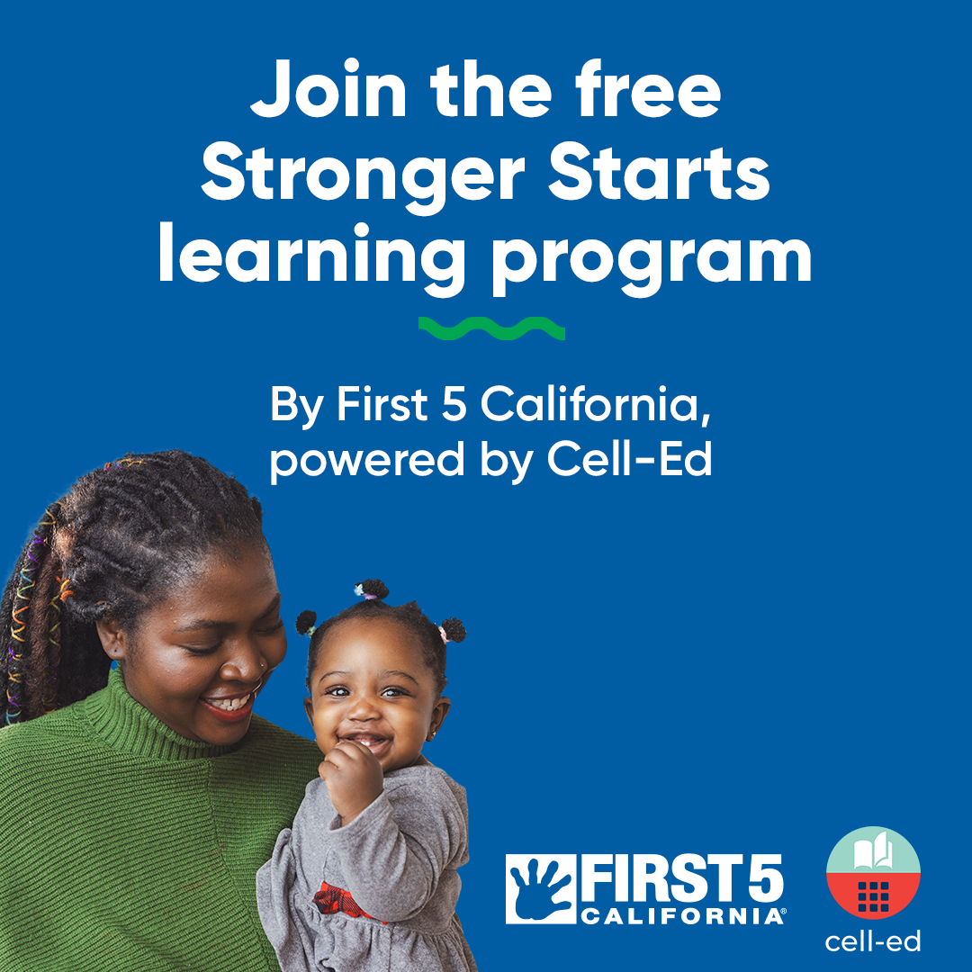
[Link to Image]

Copy:

Stronger Starts, a learning program brought to you by First 5 California and powered by Cell-Ed, is a free, mobile-friendly parenting support program designed to meet families where they are.

Caregivers receive short, trauma-informed text and audio lessons, age-based tips, and live coaching in English and Spanish—no smartphone, Wi-Fi, or computer required. Courses help families build positive routines, manage challenging moments, strengthen bonds, and even access trusted resources. Community partners can easily share Stronger Starts with families using ready-to-go flyers, QR codes, and messaging found in the toolkit. It's as easy as 1, 2, 3.

1) Sign up for the toolkit, 2) register for an upcoming webinar, and 3) watch the short overview video to see how you can start connecting families to this powerful resource today.

Have questions, want additional training or need more information? Contact Cell-Ed at customersuccess@cell-ed.com.

Social Media

Assets (Carousel):
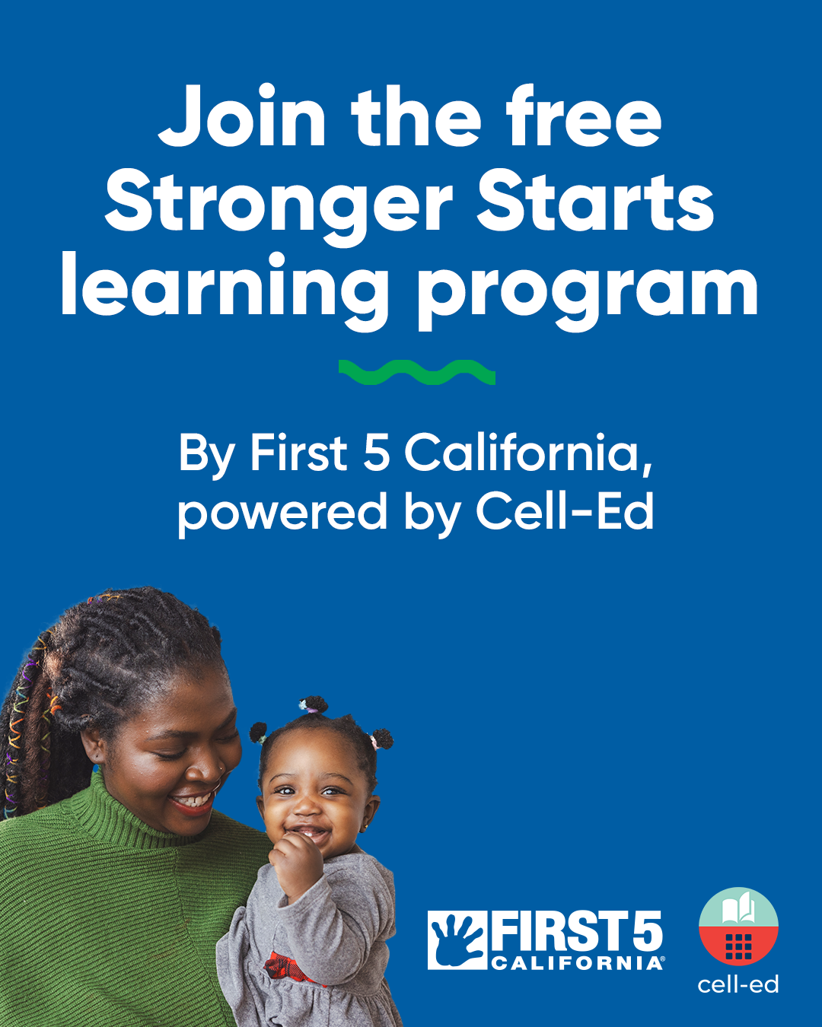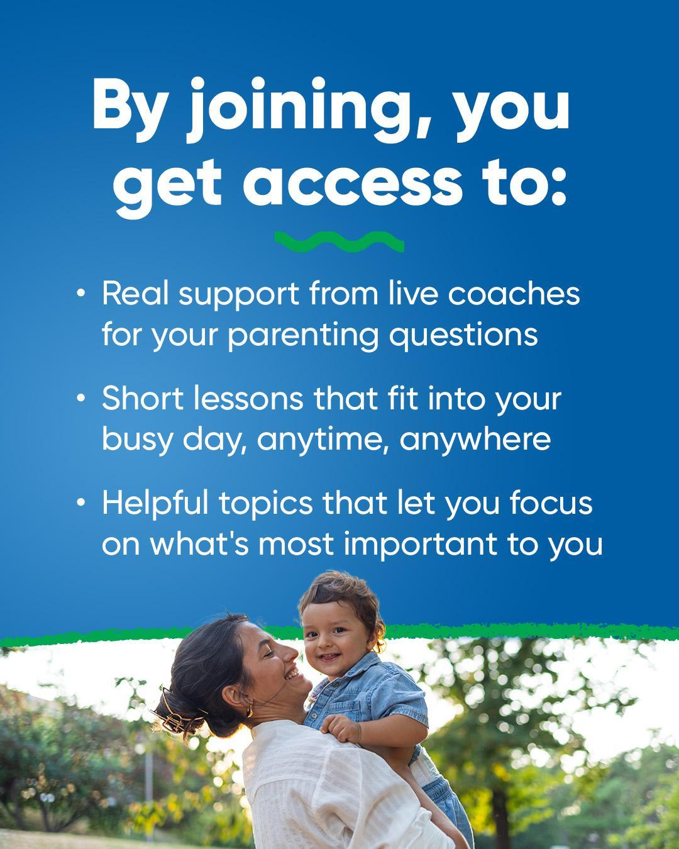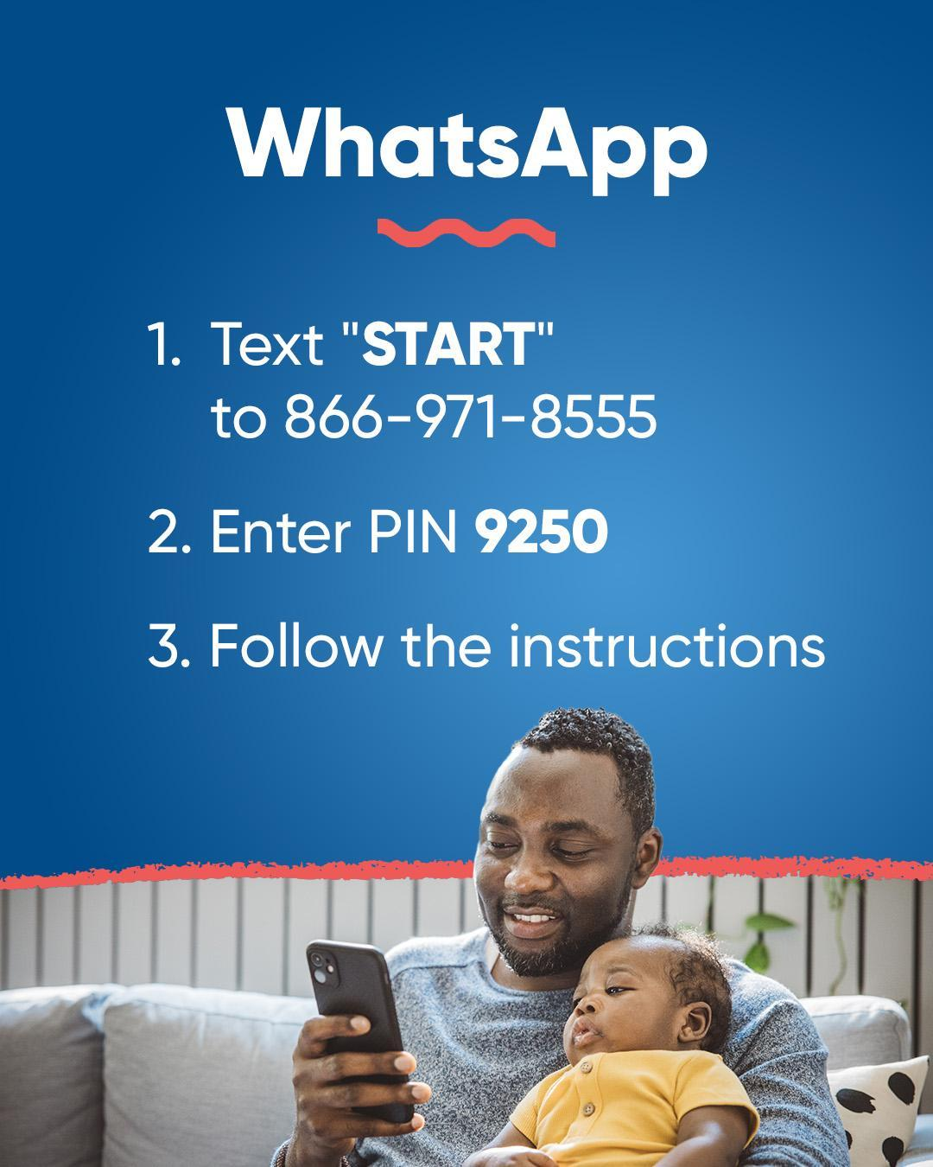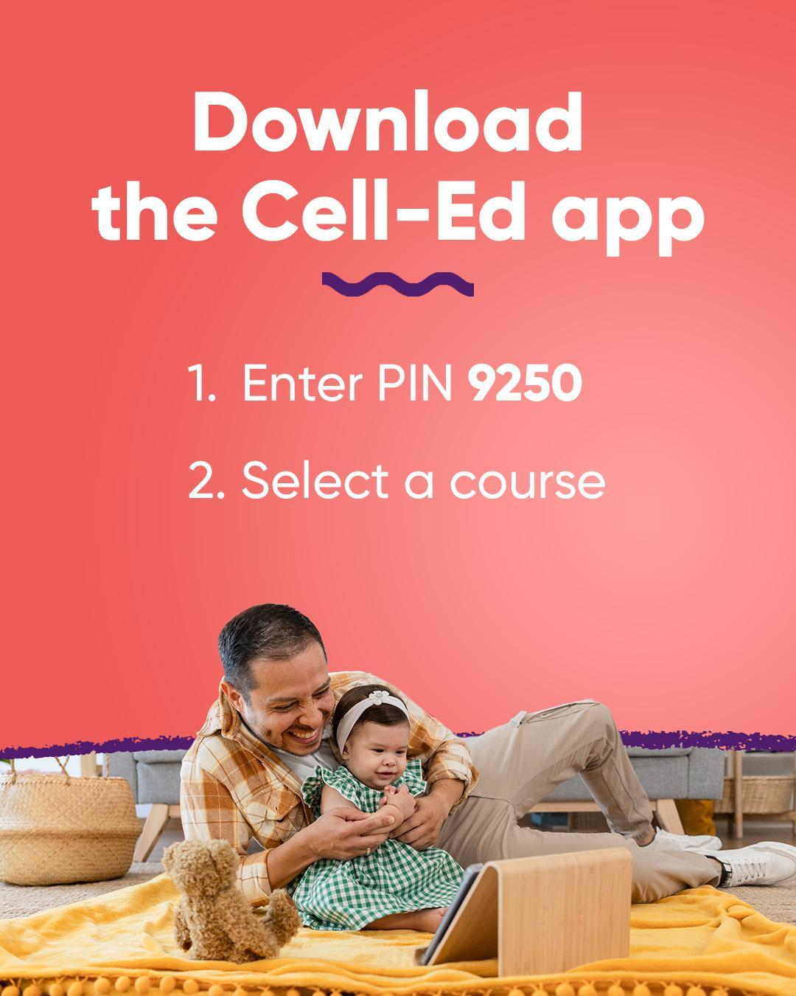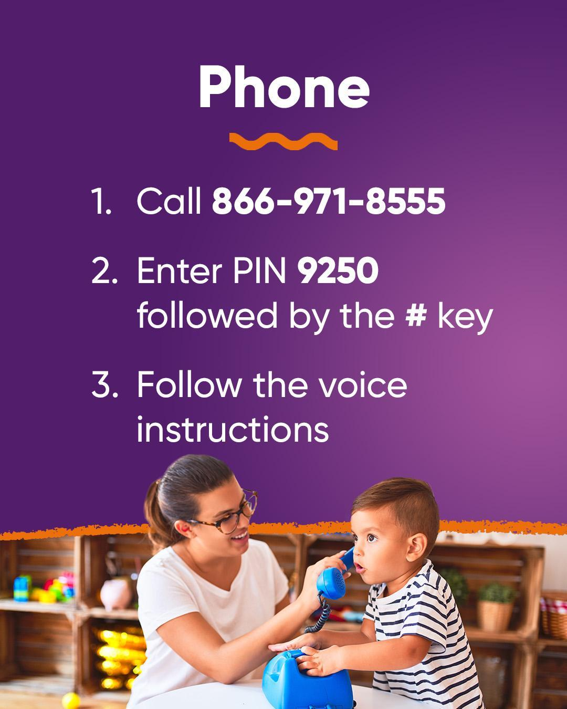
[Link to Images]

Copy:

Join First 5 California's free Stronger Starts learning program, powered by Cell-Ed.  Get access to parenting support, including:

 Mentoring from live coaches
Practical tips you can use right away
Short lessons on a variety of topics

Choose a sign-up option that works for you. To learn more, see https://bit.ly/4lec666.

Spanish
F5CA Stronger Starts
Local First 5 Newsletter & Social Media Copy

Newsletter

Asset:
[Link to Image]

Copy:

Stronger Starts, a learning program brought to you by First 5 California and powered by Cell-Ed, is a free, mobile-friendly parenting support program designed to meet families where they are.

Stronger Starts, un programa de aprendizaje presentado por First 5 California y desarrollado por Cell-Ed, es un programa gratuito y accesible desde dispositivos móviles que brinda apoyo a la crianza y está diseñado para llegar a las familias donde se encuentren.

Caregivers receive short, trauma-informed text and audio lessons, age-based tips, and live coaching in English and Spanish—no smartphone, Wi-Fi, or computer required. Courses help families build positive routines, manage challenging moments, strengthen bonds, and even access trusted resources. Community partners can easily share Stronger Starts with families using ready-to-go flyers, QR codes, and messaging found in the toolkit. It's as easy as 1, 2, 3.

1) Sign up for the toolkit, 2) register for an upcoming webinar, and 3) watch the short overview video to see how you can start connecting families to this powerful resource today.

Have questions, want additional training or need more information? Contact Cell-Ed at customersuccess@cell-ed.com.

Social Media

Assets (Carousel):
[Link to Images]

Copy:

Join First 5 California's free Stronger Starts learning program, powered by Cell-Ed. Get access to parenting support, including:

Mentoring from live coaches
Practical tips you can use right away
Short lessons on a variety of topics

Choose a sign-up option that works for you. To learn more, see https://bit.ly/4lec666.

